|  |  |  |  |
| --- | --- | --- | --- |
| **Name of Student: NINAD AVINASH PATIL** | | | |
| **Roll No: 33** | | **Lab Practical Number: 3(B)** | |
| **Title of Lab Practical: Fetch Student details from database such as rollno, name, Programme (eg. MCA), Course (eg. AWT), etc.**  **Use DataReader**  **Use DataSet** | | | |
| **DOP: 26/03/2021** | | **DOS: 31/03/2021** | |
| **CO Mapped: CO1** | **PO Mapped: PO3, PO5, PO7,**  **PO12, PSO1, PSO2** | **Faculty Signature:** | **Marks:** |

**Practical No 3(B)**

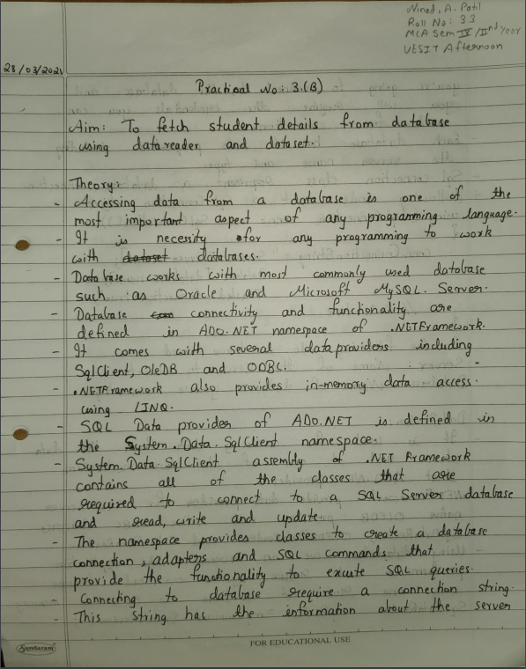

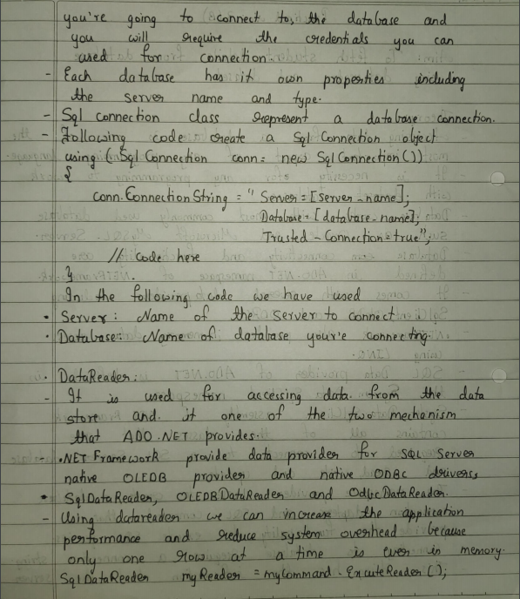



**Code:**

**WebForm1.aspx.cs**

using System;

using System.Collections.Generic;

using System.Linq;

using System.Web;

using System.Web.UI;

using System.Web.UI.WebControls;

using System.Data.SqlClient;

using System.Data;

namespace P3B

{

public partial class WebForm1 : System.Web.UI.Page

{

protected void Page_Load(object sender, EventArgs e)

{

string con = "Data Source=NINAD\\SQLEXPRESS;Initial Catalog=Student;Integrated Security=True;Pooling=False";

string sql = "Select * from MCA";

SqlConnection scon = new SqlConnection(con);

SqlCommand query = new SqlCommand(sql, scon);

scon.Open();

SqlDataAdapter sda = new SqlDataAdapter(query);

DataSet ds = new DataSet();

sda.Fill(ds);

SqlDataReader dr = query.ExecuteReader();

GridView1.DataSource = dr;

GridView1.DataBind();

GridView2.DataSource = ds;

GridView2.DataBind();

scon.Close();

}

}

}

**WebForm1.aspx**

<%@ Page Language="C#" AutoEventWireup="true" CodeBehind="WebForm1.aspx.cs" Inherits="P3B.WebForm1" %>

<!DOCTYPE html PUBLIC "-//W3C//DTD XHTML 1.0 Transitional//EN" "http://www.w3.org/TR/xhtml1/DTD/xhtml1-transitional.dtd">

<html xmlns="http://www.w3.org/1999/xhtml">

<head runat="server">

<title>Student Details</title>

</head>

<body>

<form id="form1" runat="server">

<p>

Showing data using DataReader</p>

<asp:GridView ID="GridView1" runat="server" AutoGenerateColumns="False" CellPadding="4" ForeColor="#333333" GridLines="None">

<RowStyle BackColor="#F7F6F3" ForeColor="#333333" />

<Columns>

<asp:BoundField DataField="Roll No" HeaderText="Roll No" SortExpression="Roll No" />

<asp:BoundField DataField="Name" HeaderText="Name" SortExpression="Name" />

<asp:BoundField DataField="Programme" HeaderText="Programme" SortExpression="Programme" />

<asp:BoundField DataField="Course" HeaderText="Course" SortExpression="Course" />

</Columns>

<FooterStyle BackColor="#5D7B9D" Font-Bold="True" ForeColor="White" />

<PagerStyle BackColor="#284775" ForeColor="White" HorizontalAlign="Center" />

<SelectedRowStyle BackColor="#E2DED6" Font-Bold="True" ForeColor="#333333" />

<HeaderStyle BackColor="#5D7B9D" Font-Bold="True" ForeColor="White" />

<EditRowStyle BackColor="#999999" />

<AlternatingRowStyle BackColor="White" ForeColor="#284775" />

</asp:GridView>

<br/><br/>

<p>

Showing data using DataSet</p>

<asp:GridView ID="GridView2" runat="server" AutoGenerateColumns="False" CellPadding="4" ForeColor="#333333" GridLines="None">

<RowStyle BackColor="#F7F6F3" ForeColor="#333333" />

<Columns>

<asp:BoundField DataField="Roll No" HeaderText="Roll No" SortExpression="Roll No" />

<asp:BoundField DataField="Name" HeaderText="Name" SortExpression="Name" />

<asp:BoundField DataField="Programme" HeaderText="Programme" SortExpression="Programme" />

<asp:BoundField DataField="Course" HeaderText="Course" SortExpression="Course" />

</Columns>

<FooterStyle BackColor="#5D7B9D" Font-Bold="True" ForeColor="White" />

<PagerStyle BackColor="#284775" ForeColor="White" HorizontalAlign="Center" />

<SelectedRowStyle BackColor="#E2DED6" Font-Bold="True" ForeColor="#333333" />

<HeaderStyle BackColor="#5D7B9D" Font-Bold="True" ForeColor="White" />

<EditRowStyle BackColor="#999999" />

<AlternatingRowStyle BackColor="White" ForeColor="#284775" />

</asp:GridView>

</form>

</body>

</html>

**Output:**

